**Customer Loyalty & Rewards Program**

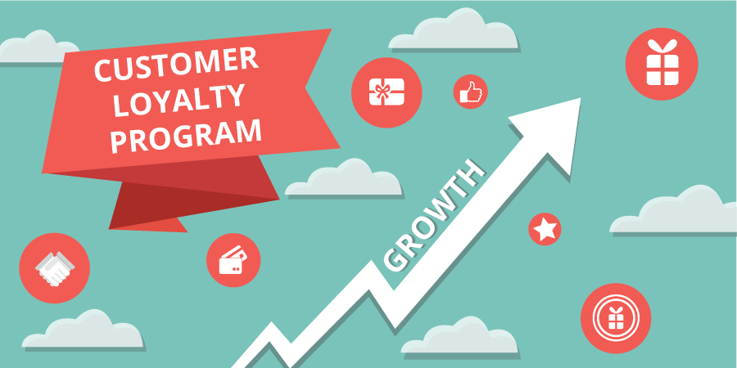

**Group 10:**

**Divi Joshi**

**Hetal Gala**

**Kunal Chopra**

**About the Business:**

As an online food delivery business owner, we have developed a customer loyalty program and rewards systems that incentivize customers to order from our business regularly or to refer new customers.

The final product is a customer loyalty program for an online food delivery service that will increase customer engagement, retain existing customers, create a competitive advantage, and increase customer lifetime value.

The customer loyalty program will provide valuable insights into customer engagement, preferences, and behavior. This information will be used to optimize the loyalty program, increase customer engagement, and inform other aspects of the business, such as marketing, product development, and customer service.

Our customer loyalty program is tailored to the unique preferences and needs of our various customer segments. This program offers personalized incentives, rewards, and exclusive offers to increase customer engagement and satisfaction. Our primary focus is on retaining our existing customers and increasing their lifetime value. By analyzing their preferences and behavior, we ensure that each customer receives offers and rewards that are relevant and appealing to them. We aim to provide our customers with a seamless and enjoyable experience that keeps them coming back for more.

We understand that our customers value convenience, personalized experiences, and value. We are committed to delivering on all these fronts through our loyalty program. Our ultimate goal is to foster stronger relationships with our customers, enhance their experience, and drive business growth. We believe that our loyalty program will help us achieve these goals and make us the go-to online food delivery service for our customers.

**Using Customer Loyalty & Rewards Program to combat against Porter’s five forces:**

To combat against the threat of new entrants, the customer loyalty program will focus on creating a strong customer base that is less likely to switch to a new food delivery service. Here are some ideas:

* **Reward customers for repeat business:** Offering rewards to customers for repeat business is a powerful way to increase customer loyalty. This includes discounts, free delivery, or other incentives that make it more attractive for customers to continue using your service. By incentivizing customers to keep ordering from the service, we are building a customer base that is less likely to switch to a competitor. We will also consider offering a tiered loyalty program where the rewards become more valuable as the customer orders more frequently.
* **Personalize offers based on customer preferences:** Personalization is a key trend in marketing today, and it can be a powerful tool for building customer loyalty. By using customer data to understand their preferences, behavior, and past orders, we will offer promotions and deals that are highly targeted and relevant to each customer. This will help to build a deeper connection with your customers and increase the chances that they will continue to order from the service.
* **Partner with local businesses:** Partnering with local businesses is a great way to create a sense of community and loyalty around the brand. By offering exclusive discounts or promotions to customers who order from the service, we will build a relationship with these businesses and help to support the local economy. This can help to differentiate the service from competitors and create a more loyal customer base.
* **Offer Early Access to New Restaurant Partners:** Offering early access to new restaurant partners will create a sense of exclusivity and reward for loyal customers. We will be giving these customers access to new restaurants before they are available to the general public, we will make them feel special and valued. This will help to build a deeper connection with our customers and increase the chances that they will continue to order from the service.

To combat the bargaining power of buyers, the customer loyalty program will focus on creating a strong relationship between customers and the food delivery business. Here are some ideas:

* **Offer Rewards for Referrals:** Referral programs are a great way to incentivize your current customers to bring in new customers. By offering rewards or discounts, we will motivate our customers to spread the word about your business and attract new customers. This will create a network effect where more customers are referring more people, leading to increased customer loyalty and brand awareness.
* **Offer Personalized Customer Service:** Personalized customer service is a key factor in building customer loyalty. By providing dedicated support channels or exclusive perks, we will make the most loyal customers feel valued and appreciated. This will create a sense of attachment and trust in the brand, which will lead to long-term loyalty.
* **Create a VIP Program:** VIP programs are a powerful way to reward the most loyal customers. By offering exclusive benefits such as early access to new features, discounts, or other perks, we will make the customers feel special and appreciated. This will lead to increased brand loyalty, as customers are more likely to continue using the service to maintain their VIP status.
* **Offer Rewards for Customer Feedback:** Customers appreciate being heard and valued. By offering rewards or discounts for providing feedback, we will incentivize customers to share their thoughts and opinions on your service. This not only helps to improve customer satisfaction but also creates a sense of ownership and engagement with the brand. It shows that we value our customers' opinions and are committed to improving their experience.

By implementing a well-designed customer loyalty program that focuses on combating against the threat of new entrants or the bargaining power of buyers, a food delivery business will increase customer retention, loyalty, and engagement, which will help the overall business to create a sustainable competitive advantage in the market.

**Strategy and Quality of customer loyalty program:**

A customer loyalty program is strategic for several reasons:

* **Helps to Retain Customers:** A customer loyalty program is an effective way to encourage customers to keep coming back to business. By offering incentives such as discounts, free products or services, or early access to new products we will encourage customers to choose your business over competitors. This can be particularly valuable in industries where there is a lot of competition, such as the restaurant or retail industries.
* **Enhances Customer Lifetime Value:** Customer lifetime value refers to the amount of revenue a customer generates over the course of their relationship with your business. By rewarding loyal customers, we will encourage them to continue doing business with you, which can increase their lifetime value. This can be especially beneficial for businesses with high customer acquisition costs, such as those in the insurance or banking industries.
* **Creates Competitive Advantage:** A well-designed customer loyalty program will differentiate our business from competitors. By offering rewards and benefits that are unique and valuable to customers, we will make it more difficult for competitors to lure your customers away. This is especially important in industries where there are many similar products or services available, such as the food or airline industries.
* **Increases Customer Engagement:** A customer loyalty program is a great way to engage customers and build stronger relationships with them. By offering exclusive benefits and rewards, we will make customers feel special and appreciated. This will lead to increased brand loyalty, as customers are more likely to stick with a business that they feel values their relationship. Additionally, loyal customers are more likely to refer friends and family to your business, which will help to increase overall customer acquisition.

In addition to these strategic benefits, a customer loyalty program is also a quality information product because it can provide valuable insights into customer behavior, preferences, and engagement. By tracking customer participation in the loyalty program, a food delivery business will gather data on which rewards and incentives are most effective, which customers are most loyal, and which customer segments are most valuable to the business.

This information can be used to optimize the loyalty program, improve customer engagement, and inform other aspects of the business such as marketing, product development, and customer service. By leveraging data and insights from the loyalty program, our food delivery business will create a more customer-centric and data-driven approach to its operations, which can help to drive growth, profitability, and customer satisfaction.

**Dataset Description:**

The following is the nature of each table [1]:

**PORTFOLIO**:

The portfolio table is a dataset that contains information about different kinds of offers that were sent to customers as part of a rewards program. The table includes the following columns:

* **Offer ID:** A unique identifier for each offer
* **Offer type:** There are three types of offers in this dataset - BOGO (buy one, get one), discount, and informational.
* **Difficulty: T**he minimum amount that must be spent to complete the offer. For BOGO and discount offers, this represents the minimum amount that must be spent to qualify for the offer.
* **Reward:** The reward for completing the offer. For BOGO offers, this represents the number of items the customer will receive for free.
* **Duration:** the number of days the offer is valid for.
* **Channels: T**he channels through which the offer was sent. This can include email, mobile app, social media, or web.

This dataset provides valuable information for businesses to understand how different types of offers and channels can impact customer behavior. By analyzing the data in this table, we have optimized the rewards programs to provide the most effective offers to their customers.

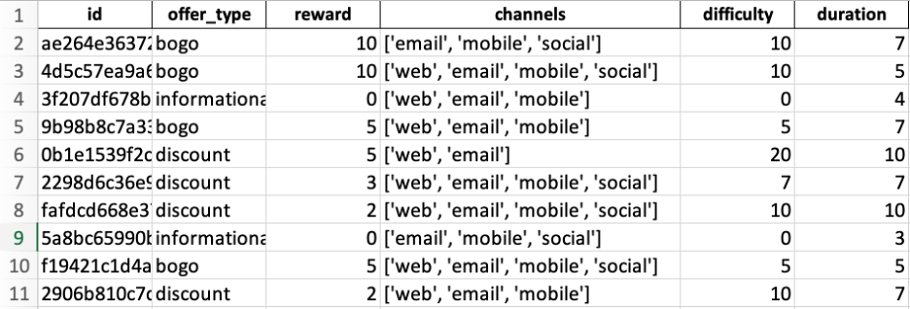

**PROFILE**:

The profile table is a dataset that lists customers who participated in a rewards program. The table includes the following columns:

* **Customer ID:** a unique identifier for each customer
* **Gender:** the customer's gender, which can be represented by either "M" for male, "F" for female, or "O" for other or unknown
* **Age:** the customer's age, represented as an integer
* **Income:** the customer's annual income, represented as a integer
* **Date Joined:** the date the customer joined the rewards program, represented as a datetime object

This dataset provides important demographic information about customers who participate in the rewards program. By analyzing the data in this table, we will gain insights into the characteristics of our customer base and tailor their rewards program to better suit their needs. For example, if a business notices that a majority of their customers are in a certain age range or have a certain income level, they may choose to offer rewards that appeal to that demographic.

In addition to demographic information, the date the customer joined the rewards program will also be useful for businesses to understand customer behavior over time. By comparing the behavior of customers who joined the program at different times, we have identify trends and patterns in customer behavior and adjust their rewards program accordingly. Overall, the profile table provides valuable information for businesses to better understand and serve their customers.

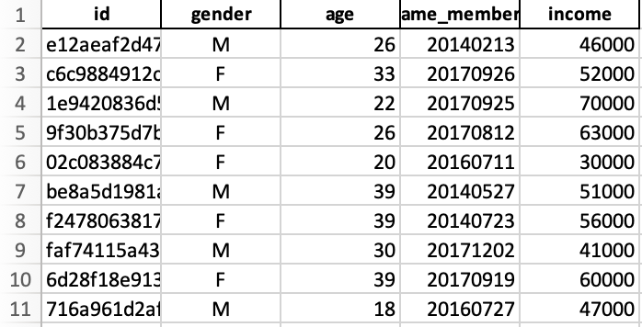

**TRANSCRIPT**:

* **Person**: A unique identifier for each customer.
* **Event**: The status of the offer whether it is in received stage, transacted, or completed.
* **Time**: The date and time the offer was completed by the customer, represented as a datetime object. If the offer was not completed, this column is represented by NaN.
* **Value**: the amount spent by the customer on a transaction associated with the offer along with the offer id, represented as a float.

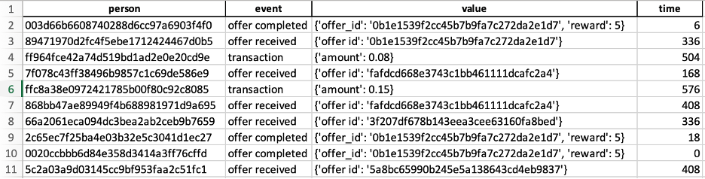

**Purpose of the datasets:**

These datasets will be used to analyze the effectiveness of customer loyalty programs and to gain insights into customer behavior and preferences for an online food delivery business.

* **PORTFOLIO:** This dataset contains information about the offers provided by the business, such as the offer type, minimum spend required, reward given, duration of the offer, and channels through which the offer is communicated. This information is used to analyze the performance of different types of offers and to identify which offers are most effective in incentivizing customers to place orders.
* **PROFILE:** This dataset contains information about the customers, including their age, gender, income, and the date they joined the app. This information is used to segment the customer base and to identify which customer segments are the most valuable to the business. It also helps to analyze the preferences and behaviors of different customer segments and to tailor loyalty programs and marketing strategies accordingly.
* **TRANSCRIPT:** This dataset contains information about the customer's interaction with the offers provided by our business, such as when an offer was received, viewed, completed, or not eligible for. This information is used to analyze the effectiveness of different offers and to identify which offers are most likely to result in customer engagement and repeat orders. It also helps to understand the customer journey and to identify areas where the loyalty program and customer experience can be improved.

The business is an online food delivery service and is developing a customer loyalty program to retain existing customers, increase customer lifetime value, create a competitive advantage, and increase customer engagement. In addition, the loyalty program may be able to provide valuable insights into the engagement, preferences, and behavior of customers. The company can gather information on which rewards and incentives are most effective and which customers are most loyal by tracking customer participation in the loyalty program. This information can be used to optimize the loyalty program, increase customer engagement, and inform other aspects of the business, such as marketing, product development, and customer service.

These data sets are critical and important because they provide valuable insights into customer behavior, preferences, and engagement. By analyzing these data sets, we can optimize the loyalty program, improve customer engagement, and inform other aspects of the business such as marketing, product development, and customer service.

**Assessing the quality of the data sets:**

Assessing the quality of a dataset is essential before any analysis because it ensures that the results obtained from the analysis are accurate and reliable. Poor-quality data can lead to inaccurate conclusions, flawed decisions, and lost opportunities. If the dataset is incomplete, inconsistent, inaccurate, outdated, irrelevant, or invalid, the analysis based on it will produce unreliable and potentially harmful results. By assessing the quality of the dataset before analysis, any issues can be identified and resolved, thereby improving the accuracy and reliability of the results. A thorough assessment of the quality of the dataset provides the necessary foundation for sound decision-making and helps prevent costly errors and poor outcomes. Therefore, it is crucial to ensure that the quality of the dataset is assessed and verified before any analysis is conducted. We have performed data quality check as per below mentioned constraints -

* **Completeness**: Is the dataset missing any values or data that isn't complete? If so, how much and where exactly? To avoid biases or errors in the analysis, we should make sure that the data is as complete as possible. The PORTFOLIO dataset seems complete as all columns appear to have values for each row. However, in the TRANSCRIPT dataset, the Time column has NaN values indicating that some offers were not completed. This missing data needs to be accounted for while analyzing the data.
* **Consistency**: Are the data consistent across various datasets and variables? For instance, do the offer ids in the TRANSCRIPT dataset and the PORTFOLIO dataset correspond to one another? Analytical mistakes can result from inconsistencies.
* **Accuracy**: How precise is the data? Are there any anomalies or errors that need to be fixed? When the data is going to be used to make decisions, it's critical to make sure that the values in the datasets are accurate and match with the expected values. The data in the PORTFOLIO and PROFILE datasets appear to be accurate since there are no obvious anomalies or errors. However, the "Value" column in the TRANSCRIPT dataset needs to be examined for accuracy since it represents the amount spent by the customer on a transaction associated with the offer.
* **Timeliness**: How recent is the data? Is it pertinent to current business requirements? The timeliness of the data needs to be checked to ensure that it is pertinent to current business requirements. The data should be recent and up to date to make better business decisions. Data that is out of date may not always be accurate or useful for making decisions.
* **Relevance**: Is the information pertinent to the current business issue or question? It is essential to make certain that the data being used is pertinent to the process of analysis and decision-making. The information provided in the datasets is pertinent to the current business issue of analyzing the effectiveness of the rewards program. However, some additional information such as customer demographics, offer effectiveness, and customer engagement rates may be required to gain a complete understanding of the program's impact.
* **Validity**: Does the data accurately reflect the intended results? Since the datasets contain self-reported customer information, it's critical to examine the validity of the data. The age, income, and gender data in the PROFILE dataset are prone to self-reporting errors or biases, which may skew the analysis. The TRANSCRIPT dataset is also prone to errors since it relies on customer reporting of the amount spent on transactions. However, no such errors were found in the datasets.

**Challenges & Learnings:**

Building a customer loyalty program for an online food delivery business can come with some challenges and learning opportunities. Some of the expected challenges and learning experiences include:

1. **Defining the right rewards and incentives:** It can be challenging to determine the right rewards and incentives that will motivate customers to participate in the loyalty program. The business will need to do research and gather customer feedback to understand what incentives are most appealing and valuable to customers.
2. **Balancing costs and benefits:** The business will need to find a balance between the cost of the rewards and incentives offered and the benefits of customer retention and engagement. It's important to ensure that the loyalty program is profitable and sustainable for the business.
3. **Creating a seamless user experience:** The loyalty program should be easy to understand, access, and participate in. The business will need to invest in developing a user-friendly interface and provide clear instructions and support to customers who participate in the program.
4. **Measuring program effectiveness:** It's important to track and measure the effectiveness of the loyalty program to understand how well it's performing and where improvements can be made. The business will need to define key performance indicators (KPIs) and set up a system to monitor and analyze the data.
5. **Adapting to changing customer preferences:** Customer preferences and behavior can change over time, and the business will need to adapt the loyalty program to reflect these changes. The business should regularly gather feedback and data from customers to identify emerging trends and preferences and adjust the program accordingly.

Overall, building a customer loyalty program for a food delivery business requires careful planning, research, and ongoing optimization. By addressing the challenges and learning opportunities that arise, the business can create a loyalty program that delivers value to both the customers and the business.

1. [**https://www.kaggle.com/datasets/blacktile/starbucks-app-customer-reward-program-data**](https://www.kaggle.com/datasets/blacktile/starbucks-app-customer-reward-program-data)